ATTENDANCE TEAM AGENDA
Meeting Objective:
Date: |  |  |  | Time:
Attendance Team Meeting Norms:
Attendance: (Indicate who is present; indicate who is not present.)
Time Frame | Time Allocated |  | Agenda Item |  |  | Owner

Truancy Intervention

GENERAL INFORMATION
Student Name: | Grade:
Parent(s)/Guardian(s):
Address:
Phone Numbers:
Referring Teacher/Team:
Student’s Teachers:
Special Program(s) (ie. Athletics, SwD):
Meeting dates on student case file: (update as meetings are held)
Why is this student being referred for attendance intervention?

STEP 1: HAS PROTOCOL BEEN FOLLOWED?
Attendance Office Procedures for Daily Absence have been followed | - Yes, continue to step 2 |  |  |  |  |  | - No, send back to Attendance Office
STEP 2: WHAT DOCUMENTATION IS PART OF THE CASE FILE?
Attendance office and/or referring team will list and attach all supporting information/documentation that will be part of this student’s case file PRIOR to Attendance Team meeting? (ie. Attendance record from Gradebook, notes from home calls, student grades).
Is there any relevant information that should be included in this case file?

STEP 3: WHAT STEP(S) HAVE ALREADY BEEN TAKEN TO REDIRECT THIS STUDENT?
Action Step(s) |  |  | Owner(s) |  | Result |  |  |  | Date of action
WHAT NEW STEP(S) WILL BE TAKEN TO REDIRECT THIS STUDENT? LIST STEPS.
Action Step(s) |  | Owner(s) |  |  |  | Result |  | Date of Implementation
PARENT CONFERENCES
If parent conference is held, indicate notes or attach supporting documentation.
Topics to be discussed should include attendance, identifying the reason(s) for the absence, and identifying the appropriate action to improve the student’s attendance.
What information was gathered from the parent meeting?

APPROPRIATE REFERRALS

Truancy Intervention SAMPLE

GENERAL INFORMATION
Student Name: John Doe | Grade: 4
Parent(s)/Guardian(s): Emily Doe
Address: 123 Main Street, Chicago, IL 60123
Phone Numbers: none
Referring Teacher/Team: Mr. Public
Student’s Teachers: Mr. Public, Ms. Dollaway, Mr. Mitty, Ms. Gatsby
Special Program(s) (ie. Athletics, SwD): none
Meeting dates on student case file: (update as meetings are held) 11/15
Why is this student being referred for attendance intervention? The student has missed 6 days of schools, all unexcused since he has started with us two months ago. The student has been late to school every day.

STEP 1: HAS PROTOCOL BEEN FOLLOWED?
Attendance Office Procedures for Daily Absence have been followed | - Yes, continue to step 2 |  |  |  | - No, send back to Attendance Office
STEP 2: WHAT DOCUMENTATION IS PART OF THE CASE FILE?
Attendance office and/or referring team will list and attach all supporting information/documentation that will be part of this student’s case file PRIOR to Attendance Team meeting? (ie. Attendance record from Gradebook, notes from home calls, student grades). |  |  | - Student Gradebook grades YTD  - Students attendance history YTD  - Students discipline history YTD  - Anecdotes from Mr. Mitty and Ms. Gatsby  - Attendance calls home per verify input
Is there any relevant information that should be included in this case file?
- The student started at our school on 9/13, two weeks after the start of the year.
- Call home have always resulted in a disconnected number
- Student has missed 6 of the 8 Mondays since he has been with us
- The student’s brother drops him off every day.
- The student does not turn in homework
STEP 3: WHAT STEP(S) HAVE ALREADY BEEN TAKEN TO REDIRECT THIS STUDENT?
Action Step(s) |  | Owner(s) |  | Result |  | Date of action
Spoke to student |  | Mr. Public |  | Student stated that he started living with his mom, and that sometimes that get up late |  | 9/30
Student home has been called each day he has been absent—emergency numbers as well |  | Attendance Office |  | No working numbers for contact |  | Starting with first absence on 9/17
A note has been given to the student to take home and signed |  | Grade level team |  | No note was returned |  | 10/1
The brother who drops him off was spoken to about the lateness and absence |  | Mr. Mitty |  | The brother stated that he knew and would try to do better |  | 10/3

WHAT NEW STEP(S) WILL BE TAKEN TO REDIRECT THIS STUDENT? LIST STEPS.
Action Step(s) | Owner(s) | Result | Date of Implementation
Hold John after school, so older brother comes into building; ask older brother to provide a working number, provide a letter and articulate a parent conference needs to be held or a home visit will be conducted | AP Bennet |  | 11/16
PARENT CONFERENCES
If parent conference is held, indicate notes or attach supporting documentation.
Topics to be discussed should include attendance, identifying the reason(s) for the absence, and identifying the appropriate action to improve the student’s attendance.
What information was gathered from the parent meeting?

APPROPRIATE REFERRALS

SAMPLE
REWARDS AND REINFORCEMENT CHART
Directions: Indicate the positive reinforcement programs in the table below.
Incentive | Requirement | Reward | Frequency | Owner | Display | Completion date
Ex. Attendance recognition  Student | 100% Attendance for the first two weeks of school | Free Ticket to Homecoming Game/locker signage | Weeks 1-5  Of School | Attendance Team | Attendance Board on 1st Floor | 10/15
Ex. Attendance recognition  Student | 95% attendance for first 5 weeks | Trip to the treasure chest or school store | 5th week | AP Johnson | Attendance Board in lunchroom | 9/25
Ex.  Attendance recognition  Classroom | 95% attendance for classroom first 5 weeks | Attendance Trophy | 5th week | AP Johnson | Classroom Doors | 9/25
Ex.  Attendance recognition  School | 95% attendance for school | Out of Uniform Day | 5th Week | Principal Crane | Attendance Board in lunchroom | 9/25
Ex. Attendance recognition  Student | 95% attendance for the first quarter | Lunch with the principal | Quarterly | Attendance Team | Attendance Board in lunchroom | 11/15

REWARDS AND REINFORCEMENT CHART
Directions: Indicate the positive reinforcement programs in the table below.
Incentive | Requirement | Reward | Frequency | Owner | Display | Completion date

TRACKING ATTENDANCE TEAM PROGRESS
INSTRUCTIONS: Provide this cover sheet with proper attachments, and submit to Network FACE Managers on a monthly basis.
ATTENDANCE TEAM ACCOUNTABILITY REVIEW
QUARTER 1
Month | August | Sept | Sept | Oct | Oct | Nov | Nov | Dec | Dec
Agenda
Sign-In Sheet
Minutes
Action Items
Action Item Follow Up/Completion
QUARTER 2
Week of:
Agenda
Sign-In Sheet
Minutes
Action Items
Action Item Follow Up/Completion
QUARTER 3
Week of:
Agenda
Sign-In Sheet
Minutes
Action Items
Action Item Follow Up/Completion
QUARTER 4
Week of:
Agenda
Sign-In Sheet
Minutes
Action Items
Action Item Follow Up/Completion

ABSENCE and TRUANCY REDUCTION STRATEGIES

HOW DO YOU START TO ADDRESS YOUR ATTENDANCE DATA?
Get an understanding of your school and it’s trends:
From Dashboard:
What you can do:
- Identify percentage of absent students from Dashboard.
- Determine what your status was at the end of last year.
- Subtract 10%. Use that as your goal.
- Break down your absence rate by Unexcused, Suspensions, and Tardies.
- Determine which factor has the most impact on your school.
- Identify a goal for improvement for the most prominent factor.
- Establish steps to address findings. For example,
  - Determine what students did not graduate, but contributed to the list of absent students from last year. Cross check their current status this year, and intercede to make sure all supports are in place for students who show patterns of behavior. This looks like collaboration with teachers, counselors, deans, and attendance teams.
  - Identify students in the current year who are struggling with attendance. Determine what department needs to intercede to provide support for the student. If the absence numbers merit home contact, this should be done.
  - Structure incentives to target specific groups/grades of students.
What you can do:
- Identify percentage of absent students from Dashboard
- Determine what your status was at the end of last year
- Subtract 15%. Use that as your goal.
- Break down your absence rate by Excused, Unexcused, Suspensions, and Tardies. Identify percentage of absent students from Dashboard
- Determine which factor has the most impact on your school.
- Identify a goal for improvement for the most prominent factor(s).
- Establish steps to address findings. For example,
  - Determine what students did not graduate, but contributed to the list of absent students from last year. Cross check their current status this year, and intercede to make sure all supports are in place for students who show patterns of behavior. This looks like collaboration with teachers, counselors, deans, and attendance teams.
  - Identify students in the current year who are struggling with attendance. Determine what department needs to intercede to provide support for the student. If the absence numbers merit home contact, this should be done.
  - Determine if certain days are showing a pattern of lesser attendance, if this is the case, with the attendance team identify ways to buoy the attendance for these days. Set school-wide goal and provide reward. If attendance is dipping on late starts or early dismissals, make sure teachers have full plans for these days. Allow students to come in college gear or career characters on these days. At the elementary level, provide lunch time games or freeze dance session.
  - Structure incentives to target specific groups/grades of students.

What you can do:
- Identify percentage of absent students from Dashboard
- Determine what your status was at the end of last year
- Subtract 20%. Use that as your goal.
- Break down your absence rate by Excused, Unexcused, Suspensions, and Tardies. Identify percentage of absent students from Dashboard
- Determine which factor has the most impact on your school.
- Identify a goal for improvement for the most prominent factor(s).
- Establish steps to address findings. For example,
  - Determine what students did not graduate, but contributed to the list of absent students from last year. Cross check their current status this year, and intercede to make sure all supports are in place for students who show patterns of behavior. This looks like collaboration with teachers, counselors, deans, and attendance teams.
  - Identify students in the current year who are struggling with attendance. Determine what department needs to intercede to provide support for the student. If the absence numbers merit home contact, this should be done.
  - Determine if certain days are showing a pattern of lesser attendance, if this is the case, with the attendance team identify ways to buoy the attendance for these days. Set school-wide goal and provide reward. If attendance is dipping on late starts or early dismissals, make sure teachers have full plans for these days. Allow students to come in college gear or career characters on these days. At the elementary level, provide lunch time games or freeze dance session.
  - Structure incentives to target specific groups/grades of students
  - Activate all necessary resources for student needs. Attendance team, in coordination with the

If chronic truancy or tardies is an issue. The efforts towards imporving attendance, does take more work.
The first componenet of working smarter, not harder is to make sure all procedures and protocols are being followed. If any step of the procedure is not completed, than your team planning is not starting from a realistic starting point. Is attendance being submitted everyday? Are home being called everyday? Are teachers remembering to go back and change all absent students to tardies for first period? Are security guards ushering students to their rooms and not letting them loitering in the hall?
Is someone posted at all entrances and waving students in who did not join teachers for during lining up
Is there a clear process when students come in late, so there are return to class is expeditious
Once this has been determined, you and your team have an honest starting point.
What you can do:
- Identify percentage of absent students from Dashboard
- Determine what your status was at the end of last year
- Subtract 20%. Use that as your goal.
- Break down your absence rate by Excused, Unexcused, Suspensions, and Tardies. Identify percentage of absent students from Dashboard
- Determine which factor has the most impact on your school.
- Identify a goal for improvement for the most prominent factor(s).

Attendance rate | Percentage of days present out of total days enrolled; attendance rate includes both excused and unexcused absences
Absence rate | Percentage of days absent out of total days enrolled; absences include excused, unexcused, suspensions, and course cutting
Chronic absentee | Student who has missed 10% or more of days enrolled (18 or more days annually)
Truant | Student with one or more unexcused absences
Chronic truant | 9 or more unexcused absences per year (5% or more of days enrolled)

WHAT ARE ATTENDANCE TERMS/STATUTES THAT SHOULD BE UNDERSTOOD?
Term | Meaning | Implications
ATTENDANCE OFFICE AND STAFF | References to “Attendance Office” in these guidelines shall mean the school designated attendance office(s) and location(s) not in the attendance office that perform attendance related activities such as the issuance of tardy passes by a school security person located at the main entrance.  Reference to “Attendance Office staff” shall mean any person assigned by the principal to perform attendance related tasks. Reference to “attendance clerk” shall mean the designated person(s) assigned to perform work, part or full-time, in the school Attendance Office regardless of their payroll job classification.
COMPULSORY ATTENDANCE | Mandated for students enrolled in grades K through 12. A K-12 student younger than age 7 or older than 17 does not have to be enrolled in school, but if enrolled, must attend or be designated a truant for unexcused absences.
COMPULSORY ENROLLMENT | Age 7 until reaching age 17 (SY 2014-15 from age 6 until reaching age 17). | - How has a student been supported to limit the option to drop at 17?  - Have students been identified prior to 17 to reduce the chance of dropping out?  - What formal interventions are in place to curtail a student from dropping out?
CONFIDENTIALITY OF STUDENT RECORDS | Other than CPS or Illinois State Board of Education (ISBE) employees/officials, no personally identifiable school student records or information may be released, transferred, disclosed or otherwise disseminated to any individual, agency or organization without the written consent of the student’s parent(s)/guardian(s).
CONTACT PERSONS DESIGNATED BY THE PARENT/  GUARDIAN | First Enrollment in a CPS School. During the student enrollment process, the parent/guardian provides the school with a student’s demographic and contact information by completing the IMPACT/SIM “School Enrollment Form”. Schools enter the contact information into the IMPACT/SIM/Demographics and Contacts records:  - The parent/guardian who has custody of the student should have the following boxes checked in “Contacts/Contact settings” section:  - “Lives with student”  - “Gets mailings for student”  - “Emergency” (contact)  - “Has permission to pick up student”  - Other designated contact persons can have the following boxes checked in the “Contacts/Contact settings” section.  - “Lives with student”  - “Gets mailings for student” (must have same address as parent/guardian that has custody)  - “Emergency” (contact)  - “Has permission to pick up student”  - The person or agency with the “Has custody of student” box checked is the person or agency whose signature is required on various CPS documents such as “Reason for Absence Notes”  - Only contacts (with the same mailing address) with the “Receives mailings” box checked will receive school-to-home mailings such as truancy notices and progress reports.  - All designated contacts should have at least one box checked in the “Contacts/Contact settings” section. If none are checked, a school can assume the person is only an emergency contact.
CONTACT PHONE NUMBER | At time of enrollment, a student’s parent/guardian is required to supply the school with at least one (1) working phone number at which they can be reached.
A "DROPOUT" | Any child enrolled in grades 9-12 who has been withdrawn from enrollment for any reason other than their death, extended illness, removal for medical non-compliance, expulsion, aging out, graduation, or completion of a program of studies and who has not transferred or is being home-schooled by the parent/guardian. | - How has a student been supported to limit the option to drop at 17?  - Have students been identified prior to 17 to reduce the chance of dropping out?  - What interventions are in place to prevent students from dropping out?  - Are these interventions organized and formal?  - How are interventions activated?
EMANCIPATED STUDENT | - As a general rule when a child reaches the age of majority (18 in Illinois), the child is emancipated, freeing the parents of any further support obligations.  - Emancipated children provide their own support. If parents agree to extend support beyond the age of majority, the child is not emancipated.  - Generally, marriage of a child or entry into the armed forces is an emancipating event. , thereby terminating a parent's responsibility for support  - Having a child is not an emancipating event.  - An emancipated student is also considered the parent/guardian of record and is authorized to sign documents normally signed by the parent/guardian (e.g. “Reason for Absence Note”).
EMERGENCY CONTACT PERSONS | A student’s parent/guardian is required to supply (and update with changes) the school with at least one (1) working phone number at which the parent/guardian can be reached.
MISSING CHILDREN REGISTRATION LAW | The parent/guardian must provide proof of student identity within 10 days for 1st time enrollments. A certified school record from the sending school is required within 14 days for transfer students.
PARENT/  GUARDIAN OF RECORD | All references to parent/guardian that appears in these guidelines shall mean the “parent/guardian or agency of record” defined as the parent(s) or legal guardian(s) or agency that is identified in the IMPACT/SIM/Contacts/Contact settings as having custody of the student. Only the parent/guardian can authorize changes/additions to the designations in the Contact settings.
A "TRUANT" | A child subject to compulsory attendance and who is absent without “valid cause” for a portion or all of a school day. | See flow chart of action steps
"VALID CAUSE“ FOR STUDENT ABSENCE | (1) illness  (2) observance of a religious holiday ("religion" for the purposes of the law, includes all aspects of religious observance and practice, as well as belief)  (3) death in the immediate family  (4) family emergency  (5) shall include such other situations beyond the control of the student as determined by the principal, or  (6) such other circumstances which cause reasonable concern to the parent for the safety or health of the student. | Has a culture of expectation been established for families to provide documentation for absences?  How has it been communicated?  Has it been communicated consistently?

WHAT ARE UNIVERSAL STEPS FOR MAKING SURE YOUR SCHOOL DATE IS ACCURATE?
- Clear up Unsubmitted Attendance
Specific students, teachers, or classes that are outstanding can be found in the error lists in the Data Quality Index (DQI) report.
- Go to Dashboard
- Click on Data Quality
- Locate your Network and your school
- The first category is Attendance; if you click on Unsubmitted Attendance located below the Attendance header, all of the classes and teachers are listed, indicating what has yet to be submitted.
- Any unsubmitted attendance should be rectified immediately so it does not accumulate, and no one has to correct attendance when the information is no longer fresh.
- Further, unsubmitted attendance does impact the overall accuracy of your attendance data.
- The image below shows what you should see on your screen.
- IMPACT provides a guide on how to rectify the situation. You can find the guide in TAB VI.
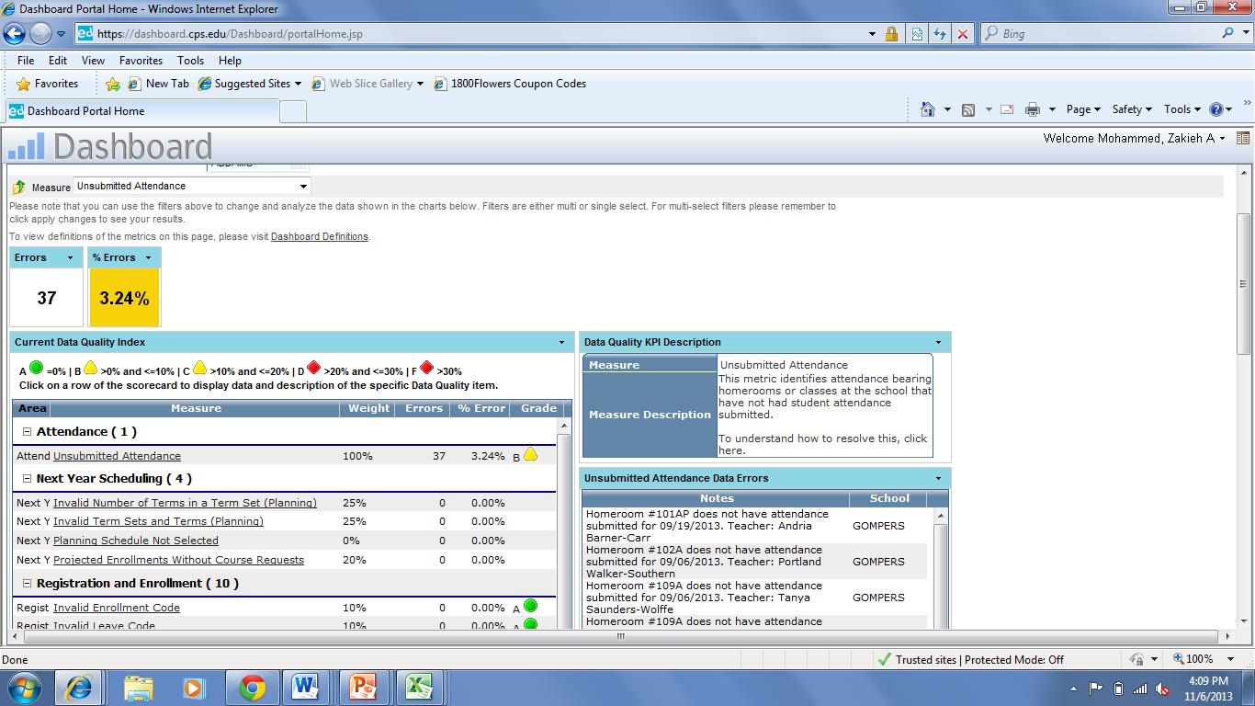
Location for Unsubmitted Attendance on DQI Report
Location for # of instances of Unsubmitted Attendance
- Specific information listing teacher/class that has Unsubmitted Attendance
- When clicked, the arrow indicated can export the information to an excel spreadsheet for easier viewing.
- Clear up all “ghost” programs.
Specific classes or sections that are impacting your data can be found in the error list in the Data Quality Index (DQI) report.
- Go to Dashboard
- Click on Data Quality
- Locate your Network and your school
- The fourth category is Scheduling; if you click on any of the subcategories [Classes Without Teacher, Homeroom N/A, Invalid Number of Terms in a Term Set, Invalid Term Sets and Terms Missing Schedules] the right side will indicate of what the error is comprised.
- Despite the safeguards to avoid programming duplication and errors, sometimes programs that are not properly closed indicate classes, as well as student attendance.
- The image below shows what you should see on your screen.
- IMPACT provides a guide on how to rectify the situation. You can find the guide in TAB VI.
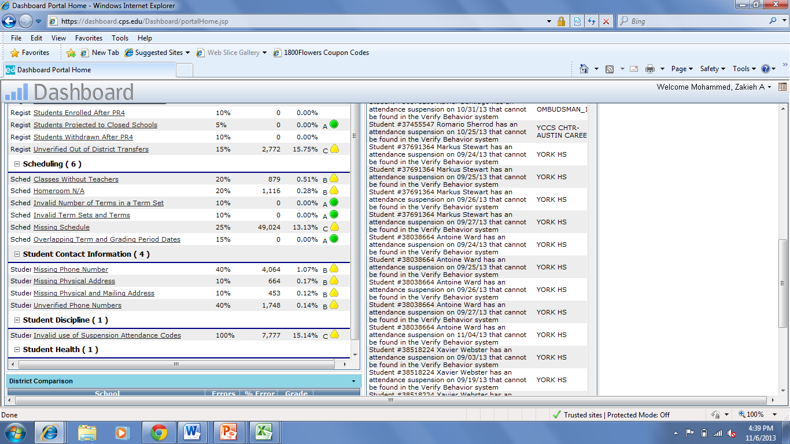
Location for Scheduling Errors on DQI Report
List of what specific errors exist appear on the right; this section is blocked to honor student confidentiality
- Cross check Gradebook and SIM Rosters—High School
- Gradebook and SIM are supposed to reflect the same information. However, it is a common problem that the Gradebook rosters and SIM Rosters did not mirror each other. To combat this issue, print all SIM Rosters, Place them in Teachers mailboxes, have them use their Gradebook rosters to cross-check accuracy. Have teachers sign off on the rosters.
- Teachers should notate any significant differences (ie. Student has never attended). Cases where students are on multiple rosters (this isn’t supposed to happen but does) Student is a DNA in one class but present in another. Student is using an old program, and a new program has been issued.

Identifying Students with Perfect Attendance
A student must have a daily attendance code of either present “P”, tardy “T”, in-school suspension “ISS” or school function “SF” for every attendance day of the period that is being considered.
1. To generate a list of students with perfect attendance for the current school year, run the IMPACT/SIM/Report/“CPS Perfect Attendance” report.
2. To identify students with perfect attendance for all school years, run the “CPS Perfect Attendance” report. Then generate the transcript for each student with current school year perfect attendance by running IMPACT/SIM/Report/“CPS HS Transcript” (requires principal, counselor, grading coordinator or status clerk IMPACT role assignment). The transcript lists the number of days present, absent and tardy by school year.

